Proceedings of the ASME 2026
International Mechanical Engineering Congress and Exposition
IMECE2026
November 8-12, 2026, Vancouver, British Columbia, Canada

IMECE2026-110495

TIME-DOMAIN SPECTRAL ELEMENT SIMULATION OF LAMB WAVE TIME REVERSAL METHOD FOR DETECTING A BREATHING CRACK IN A PLATE

Zexing Yu¹, Fei Du¹, Chao Xu¹
¹School of Astronautics of Northwestern Polytechnical University, Xi’an, China

ABSTRACT
Lamb wave is considered as an appropriate approach to detect the cracks in structures. This paper combines an efficient time-domain spectral finite element with time reversal method to develop an efficient breathing crack detection method. In this regard, Gauss-Lobatto-Legendre quadrature rules and penalty function method are carried out to construct an effective and accurate approach. Comparing the computation scales and results of this method and traditional finite element method, the validity and superiority of the proposed model is stressed. The reconstructed signals of two scenarios, intact and impaired structures, are captured. It is concluded that, this approach is capable of detecting breathing cracks. In addition, the influences of the relative depth of the notch and incident region are studied. This research may provide the guidance for experiment configuration and the further study.
SAMPLE
Keywords: Lamb waves; time reversal focusing; time-domain spectral element finite method; breaking crack; nonlinear waves

INTRODUCTION
Breathing cracks are great threats to structures, since they grow quickly and are hard to detect. Hence, many crack detection strategies have been developed in structural health monitoring. Lamb waves have been regarded as an effective way to detect the defects in structures because it can propagate over long distance and carry damage information without much attenuation [1]. However, the phenomenon, such as scattering, emission, dispersion and reflection, brings difficulties for recording and analyzing the signal in wave propagation [2]. Time reversal method can eliminate these drawbacks and establish a kind of so-called baseline-free damage detection method, which is superior in signal-to-noise ratio [3]. The process of time reversal can be simply expressed as that, a signal can be reconstructed at the excitation point if a response is reversed in time domain and reemitted to the excitation point. The principle and mathematical derivation of time reversibility can be found in many literatures [4, 5].
Time reversal method has been widely used in the field of structural health monitoring as a mature technology. H. W. Park et al combined time reversal method and wavelet-based signal processing to detect the defects in composite plates [6]. In their study, based on the Mindlin plate theory, a time reversal operator is introduced to enhance the time reversal method and their work is validated by the experimental results. B. Poddar et al developed baseline-free damage identification method by using the Lamb wave and time reversal method [7]. The influences of many parameters, such as frequency, band width, the size of sensors and tuning, are studied by experimental tools. The results show that some damages like notch, block mass and surface erosion in the wave path break the time reversibility. Hence, the distortion of waveform can be an indicator for defects. Wang et al developed an artificial time-reversal array to overcome the main drawback of traditional time reversal method, which cannot precisely reconstruct the profiles of input signals in the case of flexural waves [8]. The results demonstrate that their method has a better robustness and may reduce the sensor density without the decreasing of measured accuracy.
Detection of cracks using Lamb waves and time reversal method relates to a complex study. It requires numerical method to predict the nonlinear wave propagation and decide preferred indicators[9].The time-domain spectral finite element method (SFEM) has been used to simulate the wave propagation in different scenarios, which was proposed by Patera in fluid dynamics firstly [10]. This method can be viewed as a special type of FE method and bears some similarity with the p-version FE method [11]. The main idea of this method is the implementation of a special high-order interpolation function. In each spectral finite element, the inner interpolation nodes are collocated non-uniformly at the Gauss-Lobatto-Legendre (GLL) points, which coordinates are relative to the first derivative of nth Legendre polynomial. In this regard, the significant drawback of high-order FE method in solving wave propagation called Runge’s phenomenon can be effectively suppressed [12]. However, to the best of the authors’ knowledge, there are few

studies related to the crack detection using SFEM and time reversal method.
This paper takes advantages of the SFEM and time reversal method to develop an efficient breathing crack detection approach. Firstly, a contact spectral element is derived to model the separate cracks. The proposed method is validated by traditional finite element method (FE method) and the efficiency is addressed by comparing the mesh scale. The results demonstrate that this method can detect cracks and has potential to identify the depth and location of cracks.

THE TIME-DOMAIN SPECTRAL FINITE ELEMENT METHOD FOR BREATHING CRACKS
As shown in Fig. 1, there is a 4th order time-domain spectral finite element. The interpolation nodes are nonlinear configured at the element, different from the traditional finite element condition. This feature eliminates the influence the Runge’s phenomenon, which indicates a problem of oscillation near the edges of an interval that occurs when using polynomial interpolation with polynomials of high degree over a set of nodes spaced in a uniform grid. Hence, the high-order Lagrange polynomial function is available for SFEM without critical errors and fast convergence of dynamic simulation is achieved. For the proposed element, the coordinates of interpolation nodes are determined by GLL nodes, which are the roots of the following formulation:
SAMPLE

(1 − 𝜉𝜉²)𝑃𝑃′(𝜉𝜉), and (1 − 𝜂𝜂²)𝑃𝑃′(𝜂𝜂) (1)
The governing equation obtained by Hamilton principle is:

𝐌𝐌𝒒𝒒̈ + 𝐂𝐂𝒒𝒒̇ + 𝐊𝐊𝒒𝒒 = 𝐅𝐅(t) (2)
where 𝐌𝐌 , 𝐂𝐂 , 𝐊𝐊 and 𝐅𝐅(t) denote the mass matrix, damp matrix, stiffness matrix and external force vector, respectively and 𝒒𝒒 is the displacement vector. The definitions of matrices are expressed in many literatures and will not be described here.
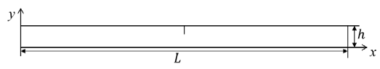
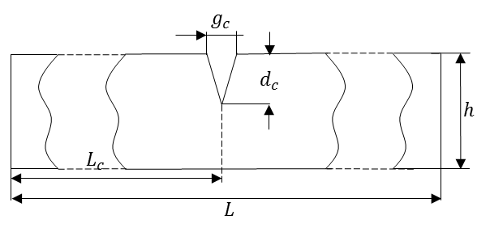
A plate with length L, thickness h and width b is illustrated in Fig. 2. At the middle of the plate, there is a single edge notch, which is V-shaped and depth is 𝑑𝑑𝑐𝑐. The surfaces of crack touch each other under the influence of external load and then separate when force is unloaded. The behavior is defined as the ‘breathing’ of cracks. In this regard, the matrices of open cracks are determined by the linear element and the Jocabian matrix is carried out to distinguish the notch element. When the crack closes, the separable hard contact model is used to simulate the contact nonlinearity.

𝑛𝑛 𝑛𝑛
where 𝑃𝑃′(𝜉𝜉), and 𝑃𝑃′(𝜂𝜂) represent the first derivative of the nth
𝑛𝑛 𝑛𝑛

order Legendre polynomial in two main direction, respectively.
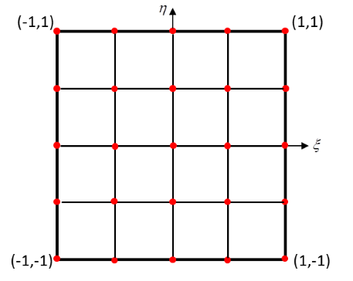

HIGH-ORDER FEM

FIGURE 2: DIAGRAM OF PLANE WITH A NOTCH.
In the case of crack model, the energy relationship of two contact surfaces can be expressed as:

Π = U − W + G (3)
where Π, U and W denote the total energy, strain energy and external work, respectively. G is constraining item for the nonlinear contact. Based on the variation principle, the total energy gets extremum when:

δΠ = δU − δW + δG = 0 (4)
the variations of stress energy and external work parts are:

δU = (𝛿𝛿𝛿𝛿)^{𝑇𝑇} σdV (5)
∫
𝑉𝑉
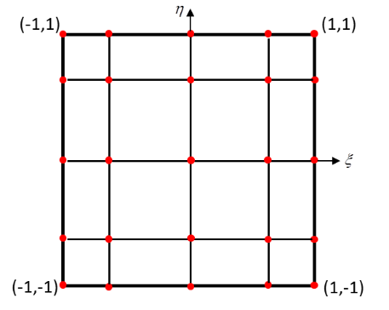
δW = ∫ (𝛿𝛿𝛿𝛿)^{𝑇𝑇}𝑃𝑃𝑑𝑑𝑃𝑃 + ∫ (𝛿𝛿𝛿𝛿)^{𝑇𝑇}𝑡𝑡𝑑𝑑Γ + ∑(𝛿𝛿𝛿𝛿)^{𝑇𝑇} 𝐹𝐹 (6)

𝑉𝑉 Γ

HIGH-ORDER SEM
FIGURE 1: THE COMPARISON OF TRADITIONAL FEM AND PROPOSED SEM
The constrain constituent G can be defined in the form of penalty function:

G = 1 ∫ 𝑔𝑔^{𝑇𝑇}Λ′𝑔𝑔𝑑𝑑Γ
(7)
or written as:

2 Γ𝑐𝑐
𝑐𝑐
𝐹𝐹_{𝑖𝑖} = −𝐹𝐹_{𝑗𝑗} = −𝐾𝐾_{𝑐𝑐}𝑑𝑑_{𝑐𝑐} + 𝐹𝐹′ (16)

where Γ𝑐𝑐 represents the contact surfaces and Λ′ =
𝑑𝑑𝑑𝑑𝑑𝑑𝑔𝑔(𝛼𝛼₁, 𝛼𝛼₂) is the penalty coefficient. 𝑔𝑔 is equation of
constrain condition.

Where

A typical situation of a contact pair is shown in the Fig. 3.
𝐾𝐾
= 𝑁𝑁 ^{𝑇𝑇}𝑇𝑇Λ𝑇𝑇^{𝑇𝑇}𝑁𝑁
(17)

Ω₁ is contactor and Ω₂ is target. The points 𝑑𝑑 and 𝑗𝑗 are
𝑐𝑐
𝑐𝑐
𝑇𝑇
𝑐𝑐

hitting point and target point and 𝐹𝐹𝑖𝑖
and 𝐹𝐹𝑗𝑗
are contact force.
𝐹𝐹′ = −𝑁𝑁_{𝑐𝑐}
𝑇𝑇Λ𝑑𝑑_{𝑝𝑝} (18)

The constrain condition can be expressed in two aspects. On one hand, impenetrability is necessary for contact behavior. It means that objects Ω₁ and Ω₂ are not allowed to invade each other during the movement. Mathematically, the gap distance is non-negative:
𝑔𝑔 = 𝑢𝑢_{𝑖𝑖} − 𝑢𝑢_{𝑗𝑗} + 𝑑𝑑_{𝑝𝑝} ≥ 0 (8)
where 𝑢𝑢𝑖𝑖 , 𝑢𝑢𝑗𝑗 and 𝑑𝑑𝑝𝑝 are displacements of points 𝑑𝑑 and 𝑗𝑗 and initial gap, respectively. On the other hand, the contact is separable; therefore, the normal contact force is always compressive force:

𝐹𝐹_{𝑖𝑖} = −𝐹𝐹_{𝑗𝑗} ≥ 0 (9)
SAMPLE
The contact force can be calculated based on Equation (4):

𝐹𝐹_{𝑖𝑖} = −𝐹𝐹_{𝑗𝑗} = −Λ𝑔𝑔 (10)
combined with Equation (8):

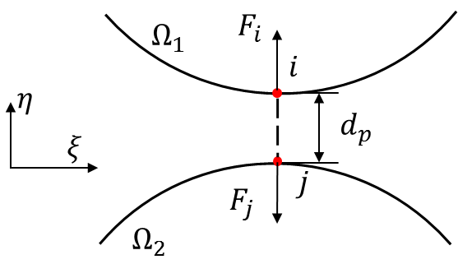
FIGURE 3: CONTACT PAIR AND THE GAP DISTANCE.
Hence, the governing equation is modified by taking account of contact as:
𝐌𝐌𝒒𝒒̈ + 𝐂𝐂𝒒𝒒̇ + (𝐊𝐊 + 𝐊𝐊_{𝐜𝐜})𝒒𝒒 = 𝐅𝐅(t) + 𝐅𝐅′(t) (19)
In our proposed strategy, the central difference scheme with suitable time step is carried out to solve the second-order differential equation. The iterative equation can be expressed when zero initial conditions, i.e., 𝒒𝒒 = 0 and 𝒒𝒒̇ = 0 at t = 0 as:

𝐹𝐹_{𝑖𝑖} = −𝐹𝐹_{𝑗𝑗} = −Λ(𝑢𝑢_{𝑖𝑖} − 𝑢𝑢_{𝑗𝑗} + 𝑑𝑑_{𝑝𝑝}) (11)
1

Δt2
𝐌𝐌𝒒𝒒t+Δt
= [𝐅𝐅(t) + 𝐅𝐅′(t)] − �𝐊𝐊 + 𝐊𝐊
_{𝐜𝐜} −

In the actual scenario, the target point is not always an element node. The displacement of target point can be calculated by the
2

Δt2
𝐌𝐌� 𝒒𝒒_{t}
− 1
Δt2
𝐌𝐌𝒒𝒒t−Δt
(20)

shape function and nodes displacements. Thus, the relative displacement of the contact pair is:

𝑢𝑢_{𝑖𝑖} − 𝑢𝑢_{𝑗𝑗} = 𝑁𝑁_{𝑐𝑐}𝑑𝑑_{𝑐𝑐} (12)
Δt denotes the time step of integration and the damping is not considered here. The explicit algorithm is conditionally stable and the stable condition is:

where 𝑁𝑁𝑐𝑐 and 𝑑𝑑𝑐𝑐 are defined as:
Δt ≤ ∆t_{cr}
= Tn
π
(21)

𝑁𝑁_{𝑐𝑐} = [𝐼𝐼_{2×2} 𝑵𝑵] (13)
where ∆tcr is the critical stable time step and Tn denotes the

𝑑𝑑

𝑐𝑐

= [𝑢𝑢_{𝑖𝑖} 𝑼𝑼]^{𝑇𝑇} (14)
minimum natural vibration period of dynamic system. It is noted that the Tn is a function of contact stiffness 𝐊𝐊𝐜𝐜. Based on the
definition of 𝐊𝐊𝐜𝐜, the penalty coefficient Λ′ = 𝑑𝑑𝑑𝑑𝑑𝑑𝑔𝑔(𝛼𝛼1, 𝛼𝛼2) is a

𝐼𝐼2×2 is square identity matrix with 2 by 2. 𝑵𝑵 and 𝑼𝑼 are shape function and nodes displacement of target element, respectively.
In addition, the coordinate transformation matrix 𝑇𝑇 is considered when the local coordinate of contact pair does not coincide with the global one. In this manner, the contact force in global system is:

𝐹𝐹_{𝑖𝑖} = −𝐹𝐹_{𝑗𝑗} = −𝑁𝑁_{𝑐𝑐}^{𝑇𝑇}𝑇𝑇Λ𝑇𝑇^{𝑇𝑇}𝑁𝑁_{𝑐𝑐}𝑑𝑑_{𝑐𝑐} − 𝑁𝑁_{𝑐𝑐}^{𝑇𝑇}𝑇𝑇Λ𝑑𝑑_{𝑝𝑝} (15)
key parameter of critical stable time step. Theoretically, the accuracy of resulting solution increases as the penalty coefficient increases. However, on one hand, the great penalty coefficient brings a tough requirement on critical stable time step, which increases the computational time. On the other hand, the contact force is proportional to the coefficient. The large penalty coefficient may result in illusive reverse[13].

MODEL VALIDATION

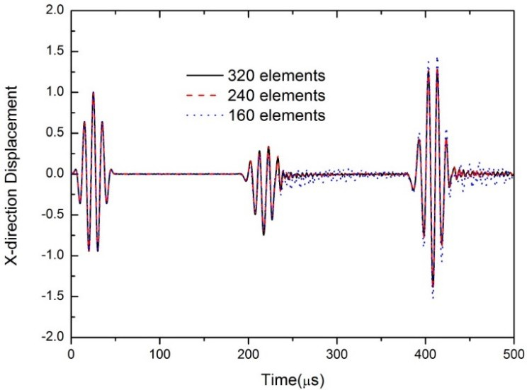
To validate the developed spectral element method, a typical aluminum structure with crack is studied in this section. The dimensions of the structure and crack are illustrated in Figure 4 and the material properties are listed in Table 1. A load is induced at the left edge in the x direction by applying a boundary displacement, which is generated by a Hanning windowed sinusoidal signal with frequency 100 kHz,

𝑃𝑃
(t) =
1
2 𝑃𝑃₀ × (1 − cos(
2𝜋𝜋𝜋𝜋

𝑛𝑛

𝑡𝑡))sin(2𝜋𝜋𝜋𝜋𝑡𝑡) (22)

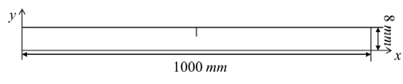
where 𝑃𝑃₀ is the peak value of the displacement and 𝑛𝑛 equals 5 which is the number of tunnels. The response is picked up at 𝑥𝑥 = 0 𝑚𝑚 edge, which is the same region as the loading.

THE DIMENSION OF PLATE.
FIGURE 5: THE RESULTS OF CONVERGENCE ANALYSIS.
In addition, the commercial software ABAQUS V6.14-1 is carried out to analyze the same work scenario. Four-node bilinear quadrilateral plane strain elements are used to mesh the structure. In the case of conventional FEM, the recommendation of element size is [14]
SAMPLE

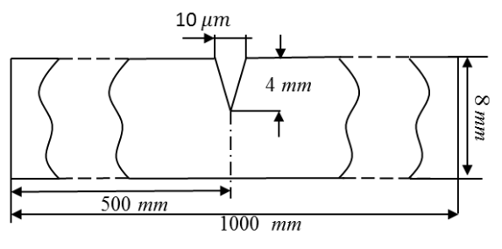
l = λmin
e
20
(23)

THE DIMENSION OF CRACK.
FIGURE 4: THE DIMENSIONS OF A PLATE WITH CRACK.

TABLE 1: THE MATERIAL PROPERTIES OF THE STRUCTURE.
where le is the element length and λmin denotes the shortest interested wavelength. The breathing crack is introduced by assigning the “frictionless hard contact” function to the crack surfaces, which can simulate the crack opens and closes due to the external load. The comparison of two kinds of results is plotted in Figure 6. It is obvious that a good agreement between two results and the second wave packet is caused by the crack.

Young’s modulus E
Density 𝜌𝜌
(kg/𝑚𝑚³)
Poisson’s Ratio ν
The result validates the effectiveness of the developed spectral element method and contact model. In addition, the

(pa)
Aluminum 7 × 10¹⁰ 2700 0.3
According to the curve of frequency thickness product, the mode of guided wave, in this case, only contains S0 and A0 modes, which can avoid the interference from other mode waves and capture the nonlinear behavior. The convergence analysis is
computational scales of two methods are list in Table 2.
Compared with conventional FEM, the proposed approach requires less computational cast and is more effective.

TABLE 2: THE COMPUTATIONAL SCALES OF TWO METHODS.

carried out to simulate the wave propagation with a reasonable
Number of elements Degree of
Time

accuracy and computational cost. In this part, three mesh scales,
freedom interval

80 × 4 = 320 elements, 60 × 4 = 240 elements and 40 × 4 = 160 elements, are demonstrated in this part and the degree
SEM 240 (with 4th interpolation)
8210 10−8 s

of interpolation is designed as 4 and the time step is chosen as 10⁻⁸ 𝑠𝑠. The penalty coefficient is defined as 1 × 10¹⁰ which order of magnitude is the same as it of the largest element of the stiffness matrix. As shown in Figure 5, the 240 case is the best mesh scale which can get an accurate result with a relative cost. In addition, the following results are normalized to compare the different strategies.
FEM 8000 18026 10−8 s

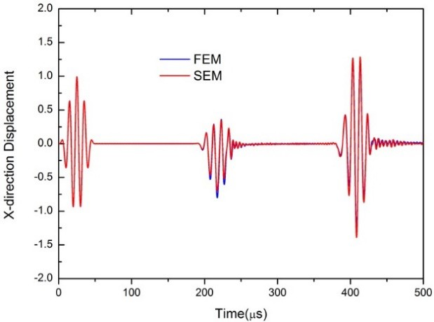
FIGURE 6: THE COMPARISON OF RESULTS OF SEM AND FEM.

NUMERICAL ANALYSIS OF TIME REVERSAL GUIDED WAVE
In this section, the time reversal method is carried out to detect the breathing crack of a specific model in Section 3. As shown in Fig.7, the process of time reversal consists of forward propagation and backward propagation. At first, the displacement excitation is applied at the left edge of the structure and the solution is captured at the right edge for 𝑡𝑡₁ = 500𝜇𝜇𝑠𝑠. Then, this response is reversed in time domain and used as the new incident wave at the right edge for the backward propagation and the response is monitoring at the left edge, which is calculated for 2𝑡𝑡₁ = 1000𝜇𝜇𝑠𝑠 to promise that the concentrated wave profile can be captured. For the sake of detecting the cracks, two structures, intact case and impaired case, are studied here.
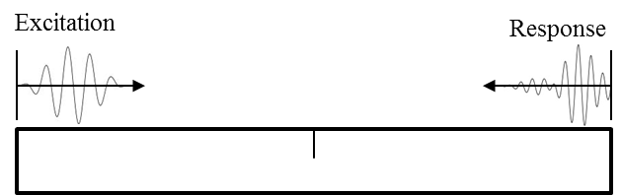

FORWARD PROPAGATION
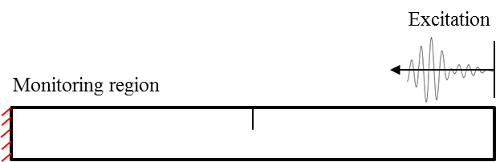

BACKWARD PROPAGATION
FIGURE 7: THE PROCEDURE OF TIME REVERSAL METHOD.
The reconstructed signals obtained for the two cases are illustrated in Fig. 8. In the case of the intact structure, the profile of reconstructed signal has a good agreement with the original input signal. However, the time reversal invariance is broken in the impaired case. The envelope of time history is obviously different form other cases, which amplitude in negative is much bigger than the positive direction. The reconstructed signals of
several depths of crack, 2 mm (25% depth), 4 mm (50% depth)and 6 mm (75% depth), are compared in Fig. 9. As shown in this figure, the profile of the signals is a function of relative depth of cracks and the distortion is more distinct as the crack grows, which has potential to be a damage indicator. In addition, when the excitation is applied at the right edge and the response is picked up at the left edge, the reconstructed signal is different and its maximum value is positive. This solution may result from that the breathing crack is like a ‘filter’, which makes the waves that open the cracks easier to pass through and those that close the cracks harder to pass. Hence, the different excitation direction results in different wave propagation although the structure is symmetric in x-axis.
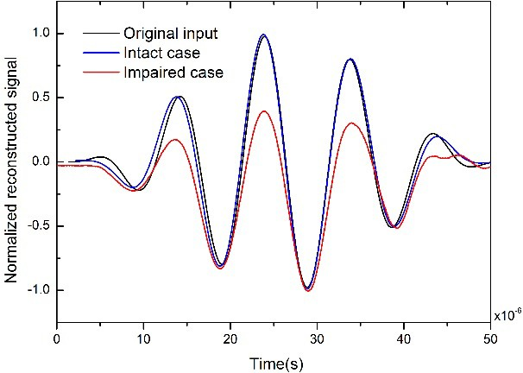

FIGURE 8: THE RECONSTRUCTED SIGNALS FOR INTACT AND IMPAIRED STRUCTURES.
SAMPLE
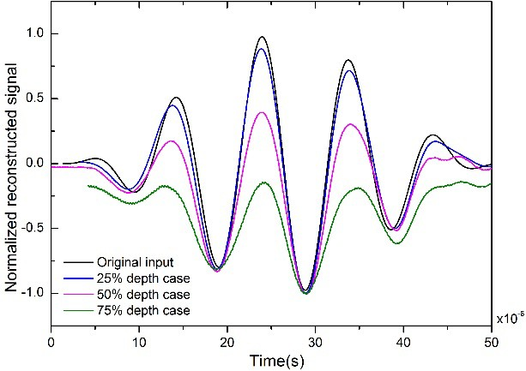

FIGURE 9: THE RECONSTRUCTED SIGNALS FOR DIFFERENT RELATIVE DEPTH.
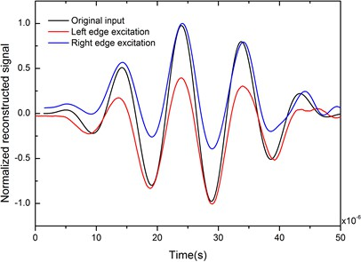
FIGURE 10: THE RECONSTRUCTED SIGNALS FOR DIFFERENT APPLIED REGION

CONCLUSION
In this paper, a novel strategy combined time-domain spectral element method and time reversal method is developed. By comparing the results and mesh scale of traditional FE method, the effectiveness and efficiency of the proposed method are illustrated. Based on the results of time reversal method, the reconstructed signals of intact and impaired structures are obviously different, which has the ability to be damage indicator. The results of different cases render that this strategy has the potential to reveal the depth and location of cracks.

ACKNOWLEDGEMENTS
This study is supported by the National Natural Science Foundation of China (Grant 51705422), China Postdoctoral Science Foundation (Grant 2018M633570), and Fundamental Research Funds for the Central Universities (Grant 3102017OQD004).

REFERENCES
- M.F. Haider, M.Y. Bhuiyan, B. Poddar, B. Lin, V. Giurgiutiu, Analytical and experimental investigation of the interaction of Lamb waves in a stiffened aluminum plate with a horizontal crack at the root of the stiffener, Journal of Sound and Vibration 431 (2018) 212-225.
SAMPLE
- W. Ostachowicz, P. Kudela, M. Krawczuk, A. Zak, Guided waves in structures for SHM, J. Wiley&Sons (2012).
- C.H. Wang, J.T. Rose, F.K. Chang, A synthetic time-reversal imaging method for structural health monitoring, Smart Materials & Structures 13(2) (2004) 415-423.
- M. Fink, Time reversed acoustics, AIP Conference Proceedings, 2001.
- Draeger, Carsten, Theory of the time-reversal process in solids, The Journal of the Acoustical Society of America 102(3) (1997) 1289.
- H.W. Park, H. Sohn, K.H. Law, C.R. Farrar, Time reversal active sensing for health monitoring of a composite plate, Journal of Sound and Vibration 302(1-2) (2007) 50-66.
- B. Poddar, A. Kumar, M. Mitra, P.M. Mujumdar, Time reversibility of a Lamb wave for damage detection in a metallic plate, Smart Materials and Structures 20(2) (2011) 025001.
- F.K. Chang, Computerized time-reversal method for structural health monitoring, Nde for Health Monitoring & Diagnostics, 2003.
- D. Fei, B. Wu, C. He, Time reversal method for guided wave inspection in pipes, Frontiers of Mechanical Engineering in China 3(3) (2008) 251-260.
- A.T. Patera, A spectral element method for fluid dynamics: Laminar flow in a channel expansion, Journal of Computational Physics 54(3) (1984) 468-488.
- Chao Xu, Z. Yu, Numerical simulation of elastic wave propagation in functionally graded cylinders using time-domain spectral finite element method, Advances in Mechanical Engineering 9(11) (2017).
- W. Ostachowicz, P. Kudela, M. Krawczuk, A. Zak, Guided Waves in Structures for SHM, Wiley & Sons2011.
- K.J. Bathe, Finite Element Method, Wiley Encyclopedia of Conputer Science and Engineering, 2000.
- F. Moser, L.J. Jacobs, J. Qu, Modeling elastic wave propagation in waveguides with the finite element method, NDT&E International 32(4) (1999) 225-234.

