TRR Sample Format Title

Author Name (Academic Example)
Department of XXX
Institution Name, City, State or Country, and Postcode
Email: author@university.edu

Author Name (Public Sector Example)
Position
XXStateXX Department of Transportation
Department (if applicable)
City, State or Country, Postcode
Email: abc@dot.gov

Author Name (Private Practitioner Example)
Position
Company
City, State or Country, Postcode
Email: enj@abc.com

Submitted [Submission Date]

ABSTRACT
The Abstract should be a stand-alone summary of the contents of the paper, equaling 250 words or less. It should present the primary objectives and scope of the study, techniques, methods or approaches briefly described and a concise summary of findings and/or conclusions reached. Please include at least three keywords, preferably five.

Keywords: Format Example, Guide, Keyword, Keyword
INTRODUCTION
This is the opening to your paper – present the background and context/major contributions for your article.

METHODS
Explain how you carried out your study in this section. Utilize subheadings (see Level 2 and Level 3 Headers) to help organize this section and the flow of your paper.

Level 2 Header
Level 2 Header/Section is for primary subsections of your paper.

Level 3 Header
Level 3 Headers/Sections are for more in-depth discussion of an idea brought up in the above Level 2 section. References should be called out numerically. (1-3). All figures and tables should be cited in the text near where they appear, i.e. (Figure 1).

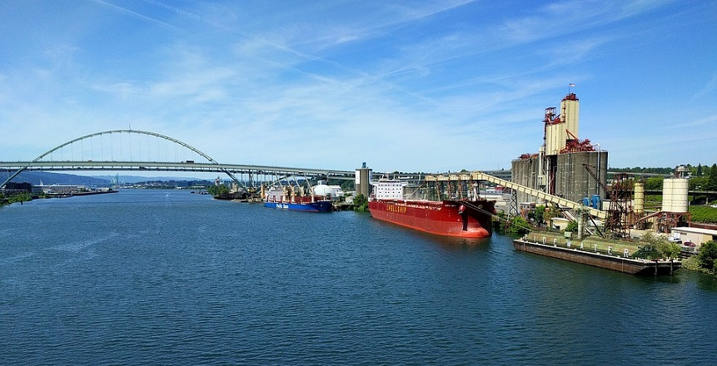

Figure 1 Caption for figure

RESULTS
This is where you present your results, without any interpretation. You will likely have most of your tables and/or figures in this section (Table 1).

TABLE 1 Measurement Conversion
When You Know | Multiply by | To Find
Length
inches (in.) | 25.4 | millimeters (mm)
feet (ft) | 0.305 | meters (m)
yards (yd) | 0.914 | meters (m)
miles (mi) | 1.61 | kilometers (km)
Area
square inches (in.²) | 645.1 | millimeters squared (mm²)
square feet (ft²) | 0.093 | meters squared (m²)
square yards (yd²) | 0.836 | meters squared (m²)
acres | 0.405 | hectares (ha)
square miles (mi²) | 2.59 | kilometers squared (km²)
Volume
fluid ounces (fl oz) | 29.57 | milliliters (mL)
gallons (gal) | 3.785 | liters (L)
cubic feet (ft³) | 0.028 | meters cubed (m³)
cubic yards (yd³) | 0.765 | meters cubed (m³)

DISCUSSION
The discussion section is where you summarize what your results mean. Equations should be cited in the text near where they appear Equation 1:

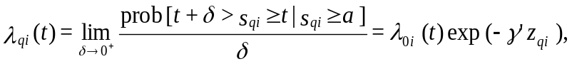 (1)

They should also be editable. Equation 2:

(2)

CONCLUSIONS

ACKNOWLEDGMENTS
This is where you place any funding information, and acknowledge any help received.

AUTHOR CONTRIBUTIONS
The authors confirm contribution to the paper as follows: study conception and design: X. Author, Y. Author; data collection: Y. Author; analysis and interpretation of results: X. Author, Y. Author. Z. Author; draft manuscript preparation: Y. Author. Z. Author. All authors reviewed the results and approved the final version of the manuscript.

REFERENCES
The Transportation Research Record utilizes Vancouver Style for references, as shown below. Reference guidelines are available in the Information for Authors.

1. Dewan, S. A., and R. E. Smith. Creating Asset Management Reports from a Local Agency
Pavement Management System. Transportation Research Record: Journal of the Transportation
Research Board, 2018. Volume: doi or page range

2. Dawley, C. B., B. L. Hogenwiede, and K. O. Anderson. Mitigation of Instability Rutting of Asphalt Concrete Pavements in Canada. Journal of Association of Asphalt Paving Technologists, 2018. 59:481–508.

3. Ghiasi, A., J. Ma, F. Zhou, and X. Li. Speed Harmonization Algorithm using Connected
Autonomous Vehicles. Presented at 96th Annual Meeting of the Transportation Research Board,
Washington, D.C., 2017.

4. Sansalone, M., J. M. Lin, and W. B. Streett. Determining the Depths of Surface-Opening Cracks
Using Impact-Generated Stress Waves and Time-of-Flight Techniques. ACI Materials Journal, 2018. 95: 168–177.

5. Newland, D. E. Random Vibrations: Spectral and Wavelet Analysis. John Wiley & Sons, Inc., New York, 1998.

6. Morcous, G., K. Wang, P. C. Taylor, and S. P. Shah. NCHRP Report 819: Self-Consolidating
Concrete for Cast-in-Place Bridge Components. Transportation Research Board, Washington, D.C., 2016. http://dx.doi.org/10.17226/23626.

7. Guide to Developing Performance-Related Specifications. FHWA-RD-98-155, FHWA- RD-98-156, FHWA-RD-98-171, Vol. III, Appendix C. www.tfhrc.gov/pavement/pccp/pavespec. Accessed March 5, 2003.

8. Von Quintus, H. L., and A. L. Simpson. Documentation of the Backcalculation of Layer Parameters for LTPP Test Sections. Publication FHWA-RD-01-113. FHWA, U.S. Department of Transportation, 2002.

9. Shunk, G. A. Urban Transportation Systems. In Transportation Planning Handbook (J. D. Edwards, Jr., ed.), Prentice Hall, Englewood Cliffs, N.J., 1992, pp. 88–122.

10. Corbett, J. J. Toward Environmental Stewardship: Charting the Course for Marine Transportation. Presented at 83rd Annual Meeting of the Transportation Research Board, Washington, D.C., 2018.

Appendices/Supplemental Material
The TRR allows appendices/supplemental material to be included with submissions. For review purposes, please place them at the end of your paper after the references. All supplemental material must be referenced in the manuscript text as well – the preferred labels for them are Table S1, Figure S2, etc.

