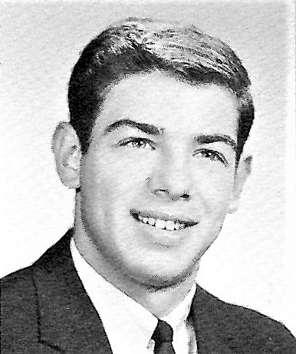
David Crescenzi
Class of 1966
Dave Crescenzi was a Milford High School player, teacher, coach and administrator ---- the "Total Package".

A three-year defensive back and two-year starting quarterback in football, he guided his team to the1964 Midland League Championship, was named a Midland League All-Star and holds the record for two of the longest TD passes "in the air": 60 yards at Fino Field and a 65-yard TD at Gallagher Field in Marlboro. As the starting 3rd baseman, he helped the baseball team win the Midland League Title in 1965, the District Championship, and the Western MA Championship compiling the best team record in the state (22-2) before losing to Somerville in the State Championship game. He led his team to another Midland League Championship his senior year batting .413 and finished his two-year starter career with 70 hits, 40 RBI’s and another Midland League All Star selection. In his four years of MHS baseball, his team swept St. Mary's in the Town Series.

Team and personal accolades continued outside of high school with a Milford Legion Zone Championship in 1965, an All-Star selection, and, in 1966, his team won the Massachusetts State Legion Championship. The captainship of the Milford AAABA Town Team followed in 1967 along with four years of baseball at Boston University playing on several ECAC Tournament teams, winning a Greater Boston League Championship, and 2 Most Spirited Player Awards. He was voted Captain of the team his senior year.

Returning to his hometown, David taught Physical Education, and as Director of Physical Education and Health he established, organized and wrote grants to implement the SADD Chapter, Health, Drug, HIV&AIDS, Diversity and Bullying education for students, teachers, parents and the community. He was a liaison to the Milford Police Department, the Governor's Alliance Against Drugs, the MA Department of Education, and District Attorney John Conte's Office, resulting in two Governor's citation awards for this work.

David served as an assistant coach for MHS baseball, football, track and soccer programs with the players and teams being extremely successful winning a number of league, district, and state championships.

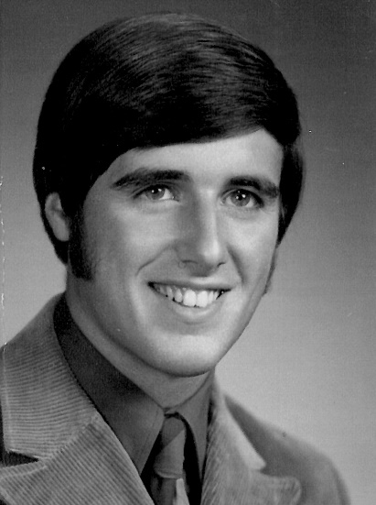
Robert Powers
Class of 1971

Robert Powers was one of the best athletes to ever compete at St. Mary’s. He earned a total of 13 Varsity Letters- 4 each in Basketball and Baseball, and 3 in Cross Country. He also managed to earn 2 letters in Track and Field while competing in baseball during the same season!

A two-year co-captain of the basketball team, Bob scored over 1,000 points during his career. An adept point guard, he made everyone around him a better player. His success on the court led to his selection to the Central Mass Catholic Conference All Star Team as both a junior and senior.

Bob was a prominent figure in the area sports pages during baseball season. The two-time captain dominated his opponents on the mound, winning over 30 games as a high school pitcher, which is the record for the town of Milford. A solid hitter who played in the field when he wasn’t pitching, Bob also holds the town record of 34 consecutive stolen bases. He led his team to four consecutive years winning the Town Series against Milford High, and had an overall record of
6 wins and only 1 loss against the crosstown rivals.

Powers also compiled a 29-3 record and a 1.12 ERA in three seasons with the Post #59 Legion Baseball Team and led them to the 1970 State Championship.

Bob received a full scholarship to the University of New Haven and was their #1 starting pitcher for four years. A 30 game winner for his career, he helped UNH to its first ever NCAA Baseball World Series appearance. He once pitched and won both games of a double-header, hurling all 18 innings, in the same day. He had four complete nine-inning games in six days that same week.

Powers finished his collegiate career as UNH’s all-time leader in appearances, wins, innings pitched, saves and complete games. He went on to play, coach and manage professionally in Italy and Europe, winning 2 Italian and 3 European Championships, twice earning Manager of the Year honors.

