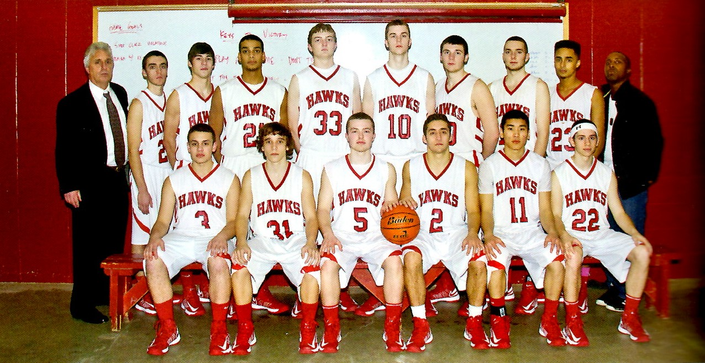
2013 Boys Basketball Team
Milford High School Hall of Fame Class of 2023
Hockomock League Champions
MIAA Division I Central Sectional Champions
MIAA Division I Final Four

The 2013 Boys Basketball team was one of the most tightly knit and equally skilled teams to ever take the court for the Scarlet Hawks. Led by eight seniors who had played together on in-town and travel teams since they began playing hoops, all averaging between nine and fourteen points per game, they went on to post a 17-3 regular season record and were crowned League Champs in Milford’s first year in the Hockomock League.
The Hawks took an immediate liking to their new league, racking up a 9-0 record in their first time around the schedule. However, they found that they needed to make some adjustments, as the teams in the Hock played stronger defenses than what they were used to playing against. They were dealt their first loss to a powerful Taunton team but regrouped to finish strong. Another loss, at the end of the season to Sharon, served as a wakeup call for the postseason.
The team opened with a solid win in the quarterfinals of the MIAA Division I Central Sectional Tournament, and then had to pull out all their tricks in a tenaciousness come-from-behind victory in the Semi’s. Down by 16 points half way through the third quarter, they beat Wachusett in a nail-biter, 46-44. They went on to down archrival St. John’s, the team that had ended their season the previous year, to win the Championship.
Head Coach Steve Manguso; Assistant Coaches Jason Potty and Shannon Ryan
Seniors- Captains Michael Titlebaum and Dave Mercier, Joe Atkinson, Scott VanBuskirk, Mike Tracy, Mike Soares, Chris Trafecante, Aaron Anniballi
Underclassmen- Chris Brown, John Calzone, Sean Fitzpatrick, Matt Grose, Jordan Johnson, Cory Knopp
Special Assistant Earl Wilson

