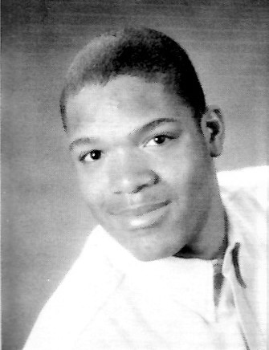
Maurice “Mo” Briscoe
Class of 1998

Maurice “Mo” Briscoe was a leader on and off the playing fields at Milford High School. A National Honor Society member and a class officer, Mo was also selected to represent MHS at Massachusetts Boys’ State.

Mo’s gregarious and easy-going nature belied the fierce competitiveness he displayed while competing in whatever sport was in season. Although he had some success in Track & Field, his strength was as a supportive and lead-by-example teammate who refused to be outworked or outhustled by his opponent. The enthusiasm with which he played was contagious!

Mo was a two-year starter in basketball. He was a fierce rebounder who fought for every missed shot, and was a reliable scorer. After earning Rookie of the Year honors as a junior, he blossomed into the team and Midland Wachusett League MVP as a senior. A team captain in 1998, he was instrumental in the team’s MIAA Division I Central Championship and a berth in the State Finals.

On the football field, Mo started 33 straight games over three seasons at defensive end, earning Rookie of the Year honors as a sophomore. He also saw significant time as an offensive tackle. Named a captain for his senior year, the 6”5”, 227 lb. Briscoe had become an absolute terror at defensive end. Mo was a two-time Midland Wachusett League All Star, 1st Team Coaches All State Team, Thanksgiving Day and Team MVP.

Mo took his talents to Fordham University, where he appeared in nine games as a freshman and was named the Sporting News’s “Top Defensive Newcomer” prior to his sophomore year. He went on to become a three-year starter, a team captain who moved to offensive tackle as senior, and a Patriot League All Star. As Fordham Coach Foley stated “Mo is impossible to replace… you’re talking about, physically, the most powerful tackle in the League…mentally, we will miss him as a captain and a leader… he’s just awesome!”


Brian Macchi
Class of 1998

Brian Macchi was a standout two-sport athlete and leader throughout his high school career at Milford High School. The 1998 Tony Correia Coaches’ Award winner’s accomplishments didn’t end there, however, as he went on to make his mark in baseball at Boston College before returning to MHS as a successful coach.

On the basketball court, Brian was a tenacious defender and reliable scorer as a two-year varsity starting forward. A senior co-captain, he was a driving force in the team capturing the Division I Central Championship and advancing to the MIAA Final Four in 1998.

Macchi was a four-year starter on the baseball diamond for Coach Charlie Stand. His athleticism and knowledge of the game allowed him to be used in almost any position on the field, mostly in the key positions of shortstop and starting pitcher. He led the team in Batting Average as well as in multiple offensive categories in each of his four years, earning Mid-Wach League All Star recognition each year. A two-year captain, he led the team to the 1997 MIAA Division I Central Championship and State Finals. He is MHS’s all-time leader with 154 hits, while also owning 24 career wins as a pitcher. Brian played four years for Milford Legion Baseball, again leading the team in a number of offensive categories, as well as five years for the Milford Town Team, which finished second in the Nationals in 1997.

At BC, Brian continued to make headlines, earning All New England and ABCA All Northeast All Star honors as both a junior and senior. In 2001, he led the Big East in homeruns and, as a senior captain in 2002, led the league in doubles, guiding the Eagles back to the Big East Tournament. Macchi was the “Eagle of the Year” recipient in 2002, which is given to only one male and one female student-athlete.

Brian served as MHS Varsity Softball Coach from 2006 – 2013, during which time the team amassed a record of 168-22, and won back-to-back MIAA Division I State Championships in 2012 and 2013.

