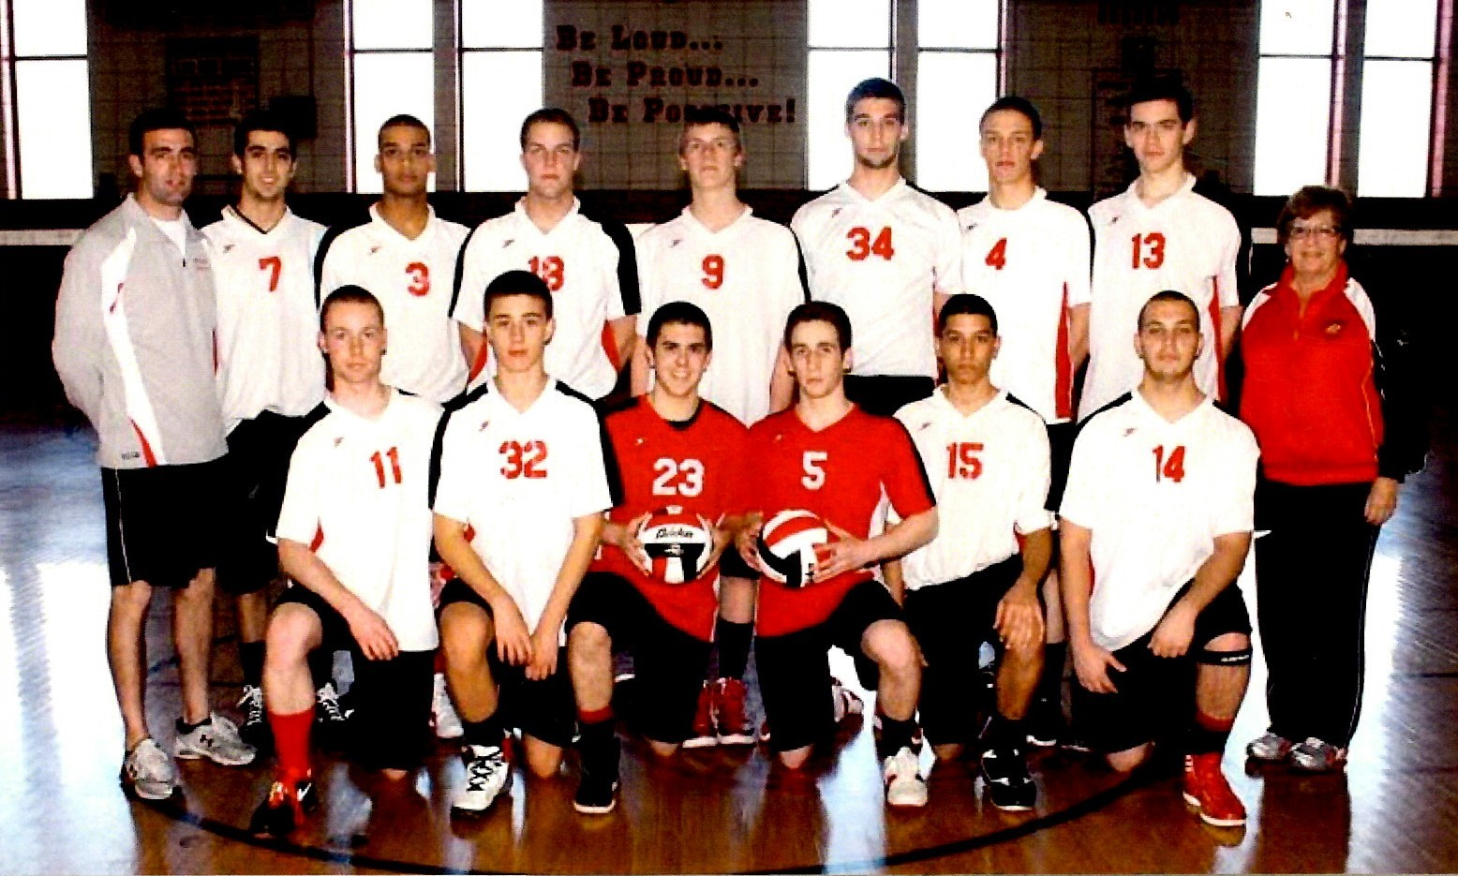
2012 Boys Volleyball
Milford High School Hall of Fame Class of 2023
League Champions
MIAA Central District Champions
MIAA State Finalist
The 2012 volleyball season produced many outstanding highlights and lasting memories. Playing a very competitive schedule, the team, coached by Linda Zacchilli, finished the regular season undefeated at 18-0. The team also competed in the Hall of Fame Tournament against the top teams in Massachusetts, finishing second to Lincoln-Sudbury; and the Rhody Invitational Tournament, showcasing the top teams in the East, where they finished second to St. Joseph’s of New Jersey. Senior Captains Dan Seaver and Alex Wasik were named to the All-Tournament Team.
As the top seed in the MIAA Central District Tournament, the Hawks ran the table, defeating both Algonquin and Xaverian, 3-0, to set up a revenge match in the Finals against Lincoln-Sudbury, a team they lost to in an early season tournament. The team answered the call with a dominant straight-set victory to win the District Championship, only the second such title in school history.
Entering the MIAA Final Four, the team knew they had to dig down deep to keep their dreams alive. They defeated a well-coached Newton North squad, 3-0, in the Semi’s, winning the final set 34-32 to advance to the Championship against number one seed, Cambridge Rindge and Latin. Cambridge won the hotly contested match, 3-2, leaving the team one match shy of their dream.
Head Coach Linda Zacchilli, Assistant Coach Peter Zacchilli
Seniors- Captains Dan Seaver and Alex Wasik, Michael Soares, Jake Archer, Chris Costa, Matt Roxo, Sean Varney; Juniors- Kane Wittorff, Anthony Lombardo, Jose Cora, Tim MacMannis, Kevin Marshall; Sophomore Michael Antonellis

