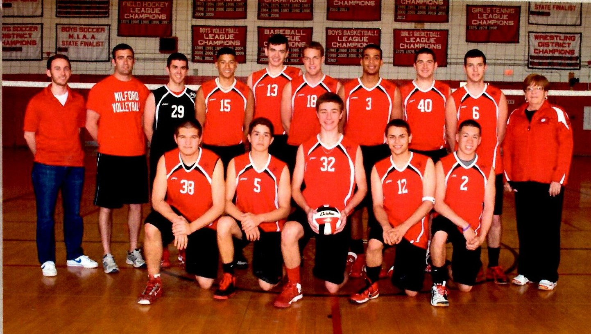
2013 Boys Volleyball
Milford High School Hall of Fame Class of 2023
MIAA Central Sectional Champions
MIAA States Finalist
Having graduated seven seniors from the 2012 State Finalist team, the 2013 squad set their goals high. They knew the effort it would take to make a repeat appearance in the State Championship game. Moving to the Hockomock League, which had only one other boys’ volleyball team, meant that the team would have to put together an independent schedule, resulting in the most competitive schedule in the history of the program.
Lawrence, Newton North, and Chicopee Comp, all 2012 Sectional Champs, as well as St. John’s Prep, loomed as obstacles in the team’s quest. They came out of the gate strong, winning their first eight matches, before dropping a match to Lawrence, who they had beaten earlier in the season. The team also defeated Newton South to win the Showcase of Champions Tournament, and lost in the finals of the Rhody Tournament for the second year in a row to St. Joseph’s of New Jersey.
Led by Senior Captains Michael Soares, Kane Wittorff and Tim MacMannis, the team finished the regular season with a record of 17-1. They went on to defeat Xaverian, Natick and Medfield on the way to winning their second straight MIAA Central Sectional Championship. They avenged their only loss of the season in the State Semifinals, defeating Lawrence in a memorable back and forth match, 3-2 (15-13), before losing, 3-1, to Western Mass Champion Agawam in the State Finals.
Head Coach Linda Zacchilli; Assistant Coaches Peter Zacchilli, Andrew Mainini Seniors- Captains Michael Soares, Kane Wittorff and Tim MacMannis; Zach Lit, Jose Cora, Kevin Marshall, Adam Zouranjian; Juniors- Carlos Rivera, Michael Antonellis; Sophomores- Erik Vega, Stevan Luna, Earl Bassett

