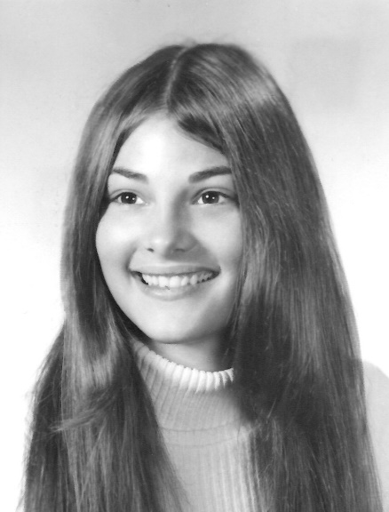
Susan Davoren
Class of 1973

Susan Davoren was a pioneer in the rise of women’s sports opportunities at Milford High School. Prior to her arrival as a freshman in the Fall of 1969, the only official team sports offered for women were basketball and softball, both with limited schedules. Sue was the beneficiary, as well as an able ambassador, of newly appointed Athletic Director Dick Corbin’s efforts to institute a full range of new sports for both men and women.

Sue was one of the first three-sport female varsity athletes in MHS history, and, as an inaugural member of the newly formed Pep Club, an enthusiastic booster of all the athletic teams. Despite her own full schedule of practices and games, as well as various school activities, she found time to serve as President of the Pep Club as a senior. She was voted Most School Spirited by her classmates.

Susan dove right in to the opportunities presented to her, becoming a member of the first field hockey team led by future Hall of Fame Coach Stephanie Slack. She took her place on defense as a Fullback, and in four short years was Tri-captain of the first Midland League Championship team in 1972. She also played four years of basketball.

Sue had her most success in high school on the softball diamond. Once again led by Coach Slack, the team rose quickly from the recreational level to the top of the competitive Midland League, winning the League Championship in 1971, 1972 and 1973. A three-year League All Star, Davoren served as a tri-captain of the 1973 team, was named team MVP, and received the most votes for League All Stars.

Susan went on to play an amazing five sports- Field Hockey, Volleyball, Basketball, Softball and Tennis- at the varsity level during her two years at Dean Junior College, and then was a member of the #1 Doubles Team for her final two years of college at Keene State, and qualified for the New England Tournament in 1978.

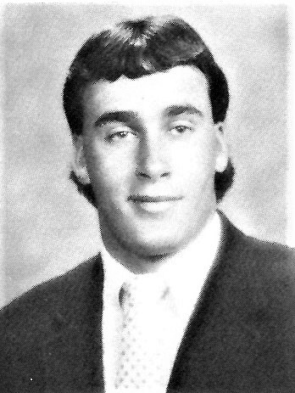
David Pyne
Class of 1988

David Pyne becomes the fourth member of the Pyne family, all outstanding linemen, to be inducted into the Milford High School Athletic Hall of Fame. His brother Jim, MHS Class of 1989, was inducted into the inaugural Class of 2001, while grandfather George II (’26) and father George III (’59) were inducted in the Class of 2004.

According to Hall of Fame Coach John Dagnese “In my 34 years of coaching football at Milford, David was one of the most dominating linemen to ever suit up, perhaps only second to his brother Jim, who had a nine-year NFL career. Dave’s size and knowledge of the game made every match-up he faced a complete mismatch.”

David was a three-year starter at offensive tackle, along with seeing significant time on defense. He was a key cog on both the 1986 and 1987 MIAA Division I Central Super Bowl Championship teams, earning Midland-Wachusett League, Milford Daily News and Worcester Telegram All Star honors.

After a year of prep school, David accepted a scholarship to Division I Lafayette University, where he was a four-year starter. As a team captain in 1993, he was selected to play in the Hula Bowl Game, which was the premier college All Star game for seniors, and signed as a free agent with the NY Giants before his release in 1994.

David coached Pop Warner Football for many years in Milford, and also as a volunteer line coach at MHS during the 2011 and 2012 seasons.

