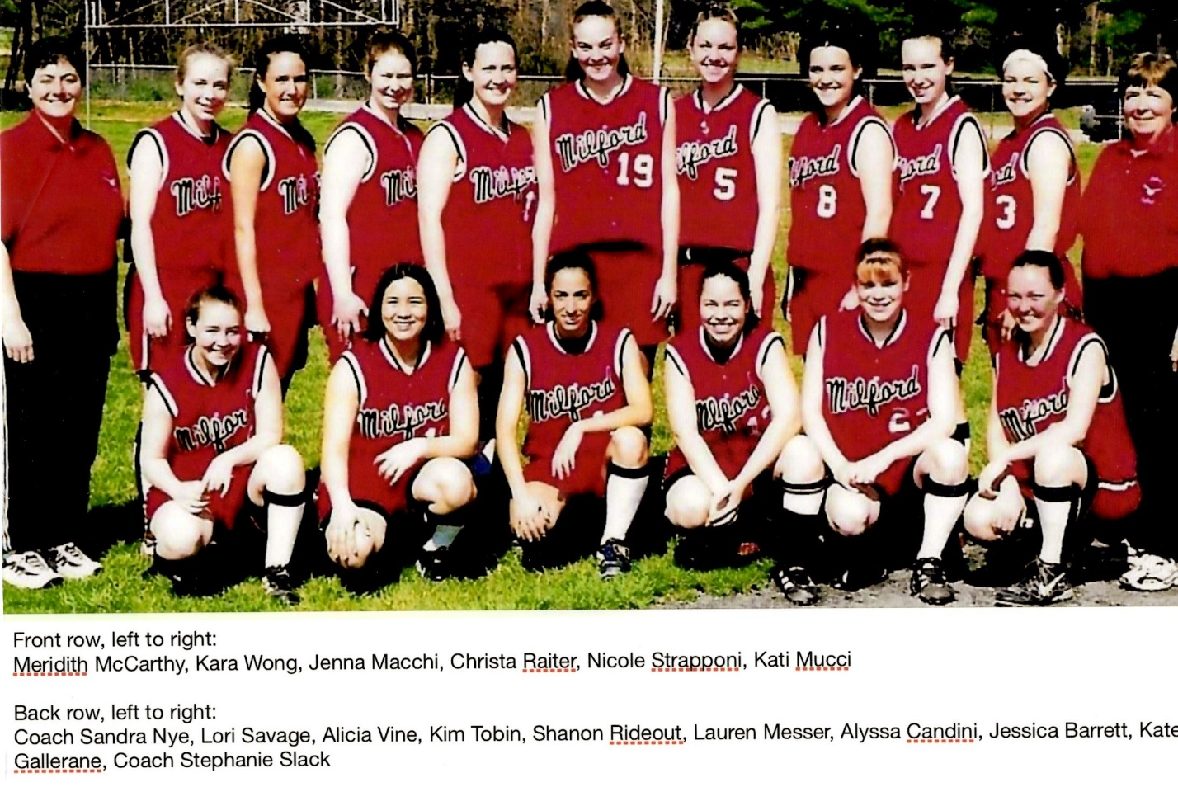
2002 Softball Team
Milford High School Hall of Fame Class of 2023
Midland-Wachusett League “A” Champions
MIAA Central Division I Champions
MIAA Division I Final Four

The 2002 Softball team, led by MetroWest Coach of the Year Stephanie Slack and Assistant Coach Sandy Nye, compiled an overall season record of 20 wins against 4 losses. The team won the Midland-Wachusett “A” League Championship, and followed that up with the school’s first Central Mass Division 1 Softball Championship.
Their regular season was a demonstration of dedication and focus during both practice and games. Their efforts and skills allowed them to post a 17-3 regular season record while representing MHS at the highest level of sportsmanship. With the leadership of seven seniors, two outstanding pitchers, a League Co-MVP catcher and strong defense, Milford was a difficult team to beat.
The team was able to perform flawlessly under pressure during several extra-inning games. This ability propelled them through the playoffs, as they won both the District Semi-finals, 2-1 in 13 innings against St. Peter-Marian, and the Championship game, 1-0 in fourteen innings against Oakmont. The season came to a close with a 3-1 loss to Western Mass Champion, Minnechaug.
Three players- pitchers Alicia Vine and Shannon Rideout, and catcher Jenna Macchi- were to the MetroWest All Star Team. Alyssa Candini and Jamie Locke were named Second Team All Stars, while Jess Barrett, Nicole Strapponi and Lori Savage received Honorable Mention.

