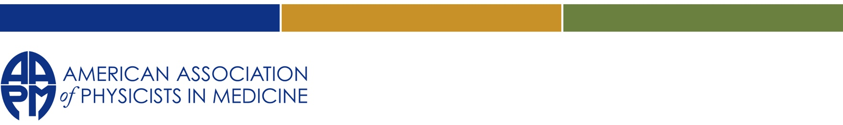
2025 AAPM/RSNA Doctoral and
Masters Graduate Fellowships Application

Application Deadline: April 17, 2025

- Doctoral Graduate Fellowships:
Four Doctoral (PhD/DMP) Awards of $10,000 each
Two awards will be for first year Doctoral Students - Students accepted (incoming) into a PhD program (currently in undergrad)
Two awards will be for Doctorate Ongoing – Students currently in their PhD programs (either 1, 2, 3, or 4th year)
• Paid to institution which in turn transfers it to student. Money can be used for tuition, professional and research development.
MS Graduate Fellowships:
Three MS Awards of $10,000 each
All first and second year MS students are eligible to apply; students accepted (incoming) into a MSc program OR currently in their 1st or 2nd year of a MSc program.
• Paid to institution which in turn transfers it to student. Money can be used for tuition, professional and research development.
- Each first-year applicant (either for Doctoral or Masters Fellowship) must be a graduate of an undergraduate program in physics or equivalent majors (e.g. engineering-physics, math-physics, or nuclear engineering or applied physics) from an accredited university or college in North America. The undergraduate grade point average must be greater than 3.5 (Based on a 4.0 scale). Each applicant must have submitted an application for graduate study to one of the CAMPEP accredited programs with subsequent acceptance.
- Each second-year or higher applicant (either for Doctoral or Masters Fellowship) must be enrolled in a CAMPEP accredited graduate medical physics program. For second-year applicants, the first semester graduate grade point average must be greater than 3.5 (based on a 4.0 scale). For higher than second-year, the graduate grade point average must be greater than 3.5 (based on a 4.0 scale).

- A comprehensive list of CAMPEP-accredited programs can be found on the CAMPEP Web Page: https://www.campep.org/

- At least one of each of the MS and Doctoral awards will be reserved for under-represented applicants

- Must be a member of the AAPM at the time of application. (Any membership category. Pending membership status not eligible.)

Required Supporting Documentation:
In addition to the completed and uploaded application form (see below; includes CV template) --

- Send all post-secondary study transcripts (Official Transcripts) to grantsandfellowships@aapm.org to arrive by the deadline.
- Upload Graduate Record Exam results (if applicable).
- Provide the recommendation form template to TWO recommenders; Two completed recommendation forms must arrive by the deadline to be uploaded by the Administrator, grantsandfellowships@aapm.org
- One reference letter sent to grantsandfellowships@aapm.org by the deadline.
- Upload acceptance letter from intended CAMPEP Accredited Program.

APPLICATION
Combine all requested items into (1) .pdf for upload

Application Deadline: April 17, 2025
I. Personal Data

Name:

Do you currently have any funding toward your Graduate Education? Yes No (circle one)

List of current funding:

II. Fellowship Program

Name of CAMPEP-Accredited Program: Expected Start Date:

III. Post Secondary Educational History
Last School: Address:
Degree/Major: Date Expected/Awarded:

Additional Relevant Education (List most recently received degree first)

Institution Major Dates Attended Degree

1. From: To:

2. From: To:

IV. Special Circumstances
If you fail to meet only one criterion, as clearly outlined on accompanying material, please state succinctly why you think you should be considered further.

VI. Fund Statement
Provide a (<300 word) statement of how funds are to be used, and how the funds will benefit your graduate study or career should you receive the award.

VI. Personal Statement
Provide a (<300 word) statement on your interest, knowledge of and/or work experience in the field of Medical Physics. Discuss immediate and long-term career aspirations. Conclude with a discussion of your personal attributes that you believe are important and useful.

VII. Statement of Accuracy
The information provided on this application is true and complete. If determined otherwise, I understand
that the AAPM can withdraw support within 30 calendar days of my receipt of written notice of same.

Signature Date

CV Template

Your Name
Phone: (000) 000-0000  youremail@companysite.com | Mailing Address  City, ST 00000

Education
List in reverse chronological order and include dates of attendance and GPA (if applicable)

Honors and Awards
List relevant awards, fellowships, honors, grants, and academic distinctions in reverse chronological order. Include a short description if necessary.

Research Experience
List in reverse chronological order and include dates of each experience

Publications
List your publications in reverse chronological order under each category below. Please do not include papers in preparation.
Papers:

Abstracts:

Talks:

Professional Affiliations

Other (Such as community service, extracurricular activity, etc.)

